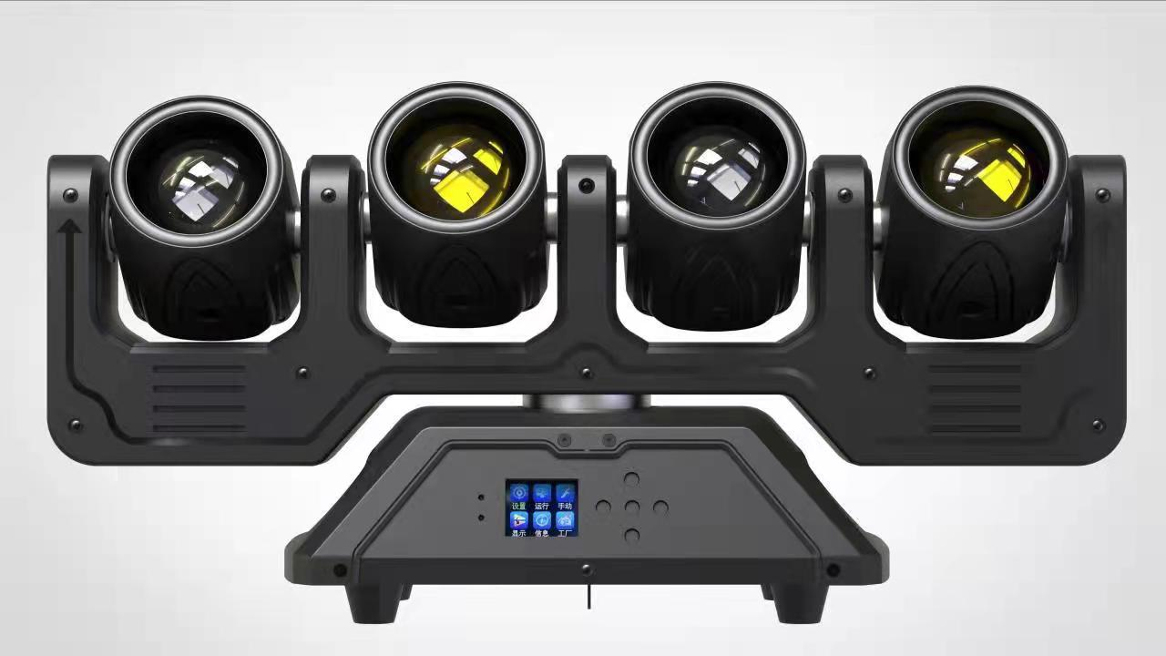
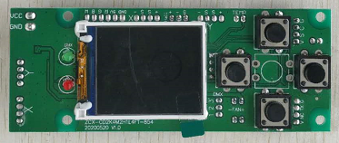I. Definition of display panel and key
Up
Signal indicator (green)
Confirm
Menu
Error indicator (red)
Down

Menu key: enter/return to the main menu
Up key: menu function select up/parameter increment
Down key: menu function select down/parameter decrement
Enter key: select the menu function, and confirm and save when modifying the menu function parameters.
II. Menu function
After the machine is powered on and reset, press the menu key to enter the main menu (exit after 30 seconds of no operation on the main menu interface). See the main menu function table for details (5 main menu options in total); Press the up or down key to select the main menu, press the enter key to modify the function parameters of each menu, and then press the enter key to save the current function parameters (with power-off memory after saving).
Main menu | Submenu | Menu function description
1. System settings | 1. DMX address | Modify the DMX address code up or down (the address code can be selected from 001-512), press the Enter key to save, and the default is 001.
1. System settings | 2. Encoder | Up or down to modify the encoder on/off, the confirmation key to save, the default on.
1. System settings | 3. X reversal | Modify X up or down to reverse on/off, enter to save, off by default.
1. System settings | 4. Y reversal | Modify Y up or down to reverse on/off, enter to save, off by default.
2. Operation mode | 1. Operation mode | Up or down to select the operating mode DMX/Voice/Auto, enter to save, default to DMX.
2. Operation mode | 2. Channel selection | Select the channel CH25/CH32/CH53 up or down, press the OK key to save, and the default is CH25.
3. Manual control | 1. X-axis | Modify the running parameter value of X motor upward or downward (the adjustable range is 000-255), press the Enter key to save, and the default value is 000.
3. Manual control | 2. X-axis fine adjustment | Modify up or down the X fine adjustment motor running parameter value (adjustable range 000-255), press the Enter key to save, and the default is 128.
3. Manual control | 3. X rotation | Modify the X rotation parameter value upward or downward (adjustable range: 000-255). Press the Enter key to save. The default value is 255.
3. Manual control | 4. Y-axis | Modify the Y-axis parameter value upward or downward (adjustable range: 000-255), press the Enter key to save, and the default value is 000.
3. Manual control | 5. Y-axis fine adjustment | Modify the Y fine adjustment parameter value upward or downward (adjustable range: 000-255), press the Enter key to save, and the default value is 000.
3. Manual control | 6. XY speed | Modify the XY speed parameter value upward or downward (adjustable range: 000-255), press the Enter key to save, and the default value is 000.
3. Manual control | 7. Dimming | Modify the value of dimming brightness upward or downward (the adjustable range is 000-255). Press the Enter key to save. The default value is 255.
3. Manual control | 8. Strobe | Modify the stroboscopic parameter value upward or downward (adjustable range: 000-255), press the Enter key to save, and the default value is 000.
3. Manual control | 9. Red | Modify the brightness of the red lamp bead upward or downward (adjustable range: 000-255). Press the Enter key to save. The default value is 255.
3. Manual control | 10. Green | Modify the brightness of the green lamp bead upward or downward (adjustable range: 000-255). Press the Enter key to save. The default value is 255.
3. Manual control | 11. Blue | Modify the brightness of the blue lamp bead upward or downward (adjustable range: 000-255). Press the Enter key to save. The default value is 255.
3. Manual control | 12. White | Modify the brightness of the white lamp bead upward or downward (adjustable range: 000-255), press the confirmation key to save, and the default value is 255.
3. Manual control | 13. Mode | Modify the mode parameter value upward or downward (the adjustable range is 000-255), press the Enter key to save, and the default is 000.
3. Manual control | 14. Speed | Modify the speed parameter value upward or downward (adjustable range: 000-255), press the Enter key to save, and the default value is 000.
3. Manual control | 15. Background color | Modify the parameter value of the background color upward or downward (the adjustable range is 000-255). Press the Enter key to save. The default value is 000.
3. Manual control | 16. Background tone light | Modify the background tone light parameter value upward or downward (the adjustable range is 000-255), press the Enter key to save, and the default value is 000.
3. Manual control | 17. Reset | When the parameter value is 250-255, the whole machine is reset. The console parameter value must be pulled below 10 and then pushed to 250-255 to be useful. When the parameter value is 000-249, it is useless and cannot be reset.
4. Display settings | 1. Language selection | Select Chinese/EN (English) up or down, and press Enter to save. The default is Chinese.
4. Display settings | 2. Inverted display settings | Select up or down to close/open the reverse display setting, and press the confirmation key to save. It is closed by default.
4. Display settings | 3. Screen saver | Select up or down to turn off/on the screen saver, press the enter key to save, and turn on by default.
4. Display settings | 4. Software version | 03 VA Program Identifier, not modifiable.
5. Factory settings | Display, please enter the password! Change up or down to 138, and then press the confirmation key to enter the factory setting. | 1. X-axis calibration | Modify the parameter up or down (range: 000-255), press the OK key to save, and the default value is 128.
5. Factory settings |  | 2. Y-axis calibration | Modify the parameter up or down (range: 000-255), press the OK key to save, and the default value is 128.
5. Factory settings |  | 3. Focus calibration | Modify the parameter up or down (range: 000-255), press the OK key to save, and the default value is 128.
5. Factory settings |  | 4. Rotation calibration | Modify the current of the red lamp bead up or down (032-255), press the confirmation key to save, and the default value is 220.
5. Factory settings |  | 5. Red | Modify the current of the green lamp bead up or down (032-255), press the OK key to save, and the default value is 220.
5. Factory settings |  | 6. Green | Up or down to modify the blue lamp current (032-255), enter the key to save, default 220.
5. Factory settings |  | 7. Blue | Up or down to modify the blue lamp current (032-255), enter the key to save, default 220.
5. Factory settings |  | 8. White | Modify the current of the white lamp bead up or down (032-255), press the OK key to save, and the default value is 220.
5. Factory settings |  | 9. Speed | Change the speed parameter up or down (range: 000-255), press the OK key to save, and the default value is 065.
5. Factory settings |  | 10. Current | Select 000/007 up or down, press Enter to save, and the default is 000.
5. Factory settings |  | 11、Logo | Select 000/001 up or down and press OK to save. The default is 000.
5. Factory settings |  | 12. Temperature | Change the temperature parameter up or down (range 40-70), press the OK key to save, and the default value is 065.
5. Factory settings |  | 13. Temperature-Fan | Up or down to select off/on temperature-fan control, enter key to save, default on.

III. Master-slave control
Two or more identical lamps are connected by DMX three-core signal line, all lamps are modified to any address code from 001 to 512, any one is set as the host, other lamps are slave, and the display screen of all slave does not flicker; When the host computer is used to adjust the effects of gradual change, pulse change, jump change, sound control and self-walking, all slave computers shall synchronize the effects of gradual change, pulse change, jump change, sound control and self-walking.
Special note: 1. Only one host can be set for a group of lamps. If there are multiple hosts, all lamps will flash randomly and not be synchronized.
2. All lamps must work only when the DMX512 console is turned off.
IV. DMX512 control
After the address codes of all lamps are set, connect all lamps to the DMX512 console in parallel with the DMX three-core signal line. The address code stops flashing, indicating that the DMX512 console signal has been sent to the lamps. Control relevant functions with the DMX512console according to the channel description.
CH25 channel description:
Passageway | Channel value | Basic functions
1 | 000-255 | X-axis
2 | 000-255 | X is not polar
3 | 000-255 | X speed
4 | 000-255 | Y overall
5 | 000-255 | Y mode speed
6 | 000-255 | Y mode
7 | 000-255 | Y-mode amplitude
8 | 000-255 | Y mode direction
9 | 000-255 | Total Dimming (Beam Assist)
10 | 000-255 | Beam stroboscopic
11 | 000-255 | Beam R
12 | 000-255 | Beam G
13 | 000-255 | Beam B
14 | 000-255 | Beam W
15 | 000-255 | Beam pattern
16 | 000-255 | Beam pattern speed
17 | 000-255 | Auxiliary light stroboscopic
18 | 000-255 | Auxiliary light R
19 | 000-255 | Auxiliary light G
20 | 000-255 | Auxiliary light B
21 | 000-255 | Auxiliary light mode
22 | 000-255 | Auxiliary light mode speed
23 | 000-255 | Integrated mode (beam assist)
24 | 000-255 | Integrated pattern speed (beam assist)
25 | 000-255 | Reset: When the parameter value is 250-255, the whole machine is reset. The console parameter value must be pulled below 10 and then pushed to 250-255 to be useful. When the parameter value is 000-249, it is useless and cannot be reset.

CH32 channel description:
Passageway | Channel value | Basic functions
1 | 000-255 | X-axis
2 | 000-255 | X is not polar
3 | 000-255 | X Inching
4 | 000-255 | X speed
5 | 000-255 | Y overall
6 | 000-255 | Y1
7 | 000-255 | Y2
8 | 000-255 | Y3
9 | 000-255 | Y4
10 | 000-255 | Y mode speed
11 | 000-255 | Y mode
12 | 000-255 | Y-mode amplitude
13 | 000-255 | Y mode direction
14 | 000-255 | Total Dimming (Beam Assist)
15 | 000-255 | Beam stroboscopic
16 | 000-255 | Beam R
17 | 000-255 | Beam G
18 | 000-255 | Beam B
19 | 000-255 | Beam W
20 | 000-255 | Beam pattern
21 | 000-255 | Beam pattern speed
22 | 000-255 | Auxiliary light stroboscopic
23 | 000-255 | Auxiliary light R
24 | 000-255 | Auxiliary light G
25 | 000-255 | Auxiliary light B
26 | 000-255 | Auxiliary light mode
27 | 000-255 | Auxiliary light mode speed
28 | 000-255 | Integrated mode (beam assist)
29 | 000-255 | Integrated pattern speed (beam assist)
30 | 000-255 | Background color (beam assist)
31 | 000-255 | Background color dimming (beam assist)
32 | 000-255 | Reset: When the parameter value is 250-255, the whole machine is reset. The console parameter value must be pulled below 10 and then pushed to 250-255 to be useful. When the parameter value is 000-249, it is useless and cannot be reset.

CH53 channel description:
Passageway | Channel value | Basic functions
1 | 000-255 | X-axis
2 | 000-255 | X is not polar
3 | 000-255 | X Inching
4 | 000-255 | X speed
5 | 000-255 | Y overall
6 | 000-255 | Y1
7 | 000-255 | Y2
8 | 000-255 | Y3
9 | 000-255 | Y4
10 | 000-255 | Y mode speed
11 | 000-255 | Y mode
12 | 000-255 | Y-mode amplitude
13 | 000-255 | Y mode direction
14 | 000-255 | Total Dimming (Beam Assist)
15 | 000-255 | Beam stroboscopic
16 | 000-255 | Beam R1
17 | 000-255 | Beam G1
18 | 000-255 | Beam B1
19 | 000-255 | Beam W1
20 | 000-255 | Beam R2
21 | 000-255 | Beam G2
22 | 000-255 | Beam B2
23 | 000-255 | Beam W2
24 | 000-255 | Beam R3
25 | 000-255 | Beam G3
26 | 000-255 | Beam B3
27 | 000-255 | Beam W3
28 | 000-255 | Beam R4
29 | 000-255 | Beam G4
30 | 000-255 | Beam B4
31 | 000-255 | Beam W4
32 | 000-255 | Beam pattern
33 | 000-255 | Beam pattern speed
34 | 000-255 | Auxiliary light stroboscopic
35 | 000-255 | Auxiliary light R1
36 | 000-255 | Auxiliary light G1
37 | 000-255 | Auxiliary light B1
38 | 000-255 | Auxiliary light R2
39 | 000-255 | Auxiliary light G2
40 | 000-255 | Auxiliary light B2
41 | 000-255 | Auxiliary light R3
42 | 000-255 | Auxiliary light G3
43 | 000-255 | Auxiliary light B3
44 | 000-255 | Auxiliary light R4
45 | 000-255 | Auxiliary light G4
46 | 000-255 | Auxiliary light B4
47 | 000-255 | Auxiliary light mode
48 | 000-255 | Auxiliary light mode speed
49 | 000-255 | Integrated mode (beam assist)
50 | 000-255 | Integrated pattern speed (beam assist)
51 | 000-255 | Background color (beam assist)
52 | 000-255 | ? Background color dimming (beam assist)
53 | 000-255 | Reset: When the parameter value is 250-255, the whole machine is reset. The console parameter value must be pulled below 10 and then pushed to 250-255 to be useful. When the parameter value is 000-249, it is useless and cannot be reset.

V. Technical parameters:
Voltage: AC100 ~ 240V 50/60HZ
Control mode: DMX512, self-propelled, master-slave, voice control, with RDM function.
Channels: CH25, CH32, CH53
Dimming: 32bit 0 ~ 100% linear dimming
Features: XY head + beam + flash + infinite
Working temperature: -30 ℃ ~ 50 ℃
Strobe frequency: 1 ~ 30HZ
Appearance: metal, black
Connection mode: DMX512 input/output/power input/output.
IP rating: IP20
Dimensions: Height: 26 cm Length: 56 cm Width: 18 cm Weight: 7 kg

